|  |  |  |
| --- | --- | --- |
|  | **Centre Name: ACE-HCMC-2-FPT.**  **Address: 590 Cach Mang Thang 8, District 3, Ho Chi Minh City, Viet Nam.** |  |

|  |  |
| --- | --- |
|  | **FPT ACADEMY INTERNATIONAL**  **FPT – APTECH COMPUTER EDUCATION** |

ANGEL FASHION SHOP

|  |  |  |  |
| --- | --- | --- | --- |
| **Supervisor:** | Phan Minh Tâm | | |
| **Batch No.:** | F3-13-1604-T0 | | |
| **Group:** | Angel Fashion Shop | | |
| **Member:** | **Full Name** | | **Roll No.** |
|  | 1. | Lê Nguyễn Ngọc Quý | Student 911876 |
|  | 2. | Đỗ Anh Khoa | Student 904202 |
|  | 3. | Tạ Phi Bằng | Student 911119 |
|  | 4. | Trần Đình Khang Duy | Student 911128 |

Installation Guide

**12-2017**

|  |  |  |
| --- | --- | --- |
|  | **Centre Name: ACE-HCMC-2-FPT.**  **Address: 590 Cach Mang Thang 8, District 3, Ho Chi Minh City, Viet Nam.** |  |

|  |  |
| --- | --- |
|  | **FPT ACADEMY INTERNATIONAL**  **FPT – APTECH COMPUTER EDUCATION** |

**PROJECT: ANGEL FASHION SHOP**

**GROUP NO: 3, BATCH: F3-13-1604-T0**

1. **SYSTEM REQUIREMENTS**

|  |  |  |
| --- | --- | --- |
| **Sr.** | **Item** | **Description** |
| 1. | OS | Windows 7 or above |
| 2. | Database | SQL Server 2012 or above |
| 3. | JRE | Java JRE version 7 |
| 4. | JDK | Java JDK version 7 |
| 5. | GlassFish | Version 4 |
| 6. | Fonts | Only use font Unicode: Arial, Tahoma, Lucida Console, Times New Roman |

1. **INSTALLATION**

***Step 1: Copy zip file from USB to local hard disk***

* Copy file **“[Project_SEM_4]F3-13-1604-T0_Angel.rar”** from USB to local hard disk.
* Right click on file “.rar” and select “Extract here”. *(Figure 1)*
* Double click on created folder “F3-13-1604-T0-Group3” to see below folders: *(Figure 2)*
  + File project .war: **AngelShop.war**
  + File database .sql: **AngelShopDB.sql**
  + File driver SQL server for glassfish: **sqljdbc4-2.0.jar**

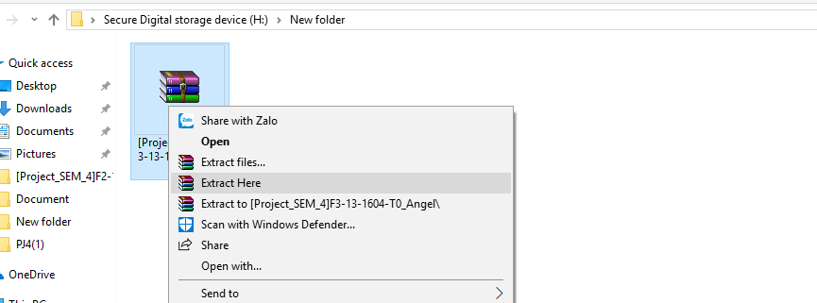

**Figure 1:** Right click on file “.rar” and select “Extract here”.

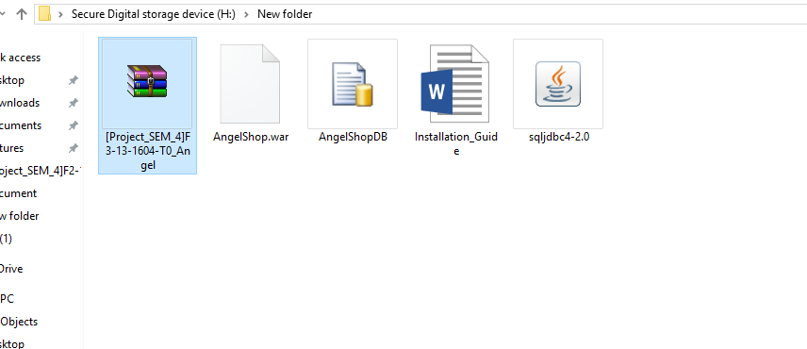

**Figure 2:** Double click on created folder “F3-13-1604-T0-Group3” to see below folders.

***Step 2: Work with “SQL Server Managerment Studio”***

* Login to “SQL Server Managerment Studio” (*Figure 3*) with your system admin account:

Login: **sa**



 Password: **123**

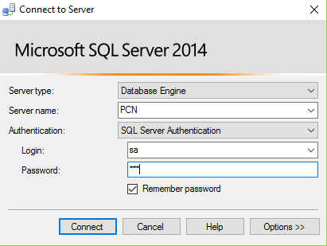

# Figure 3: Login to “SQL Server Managerment Studio”

* Open file “AngelShopDB.sql” in “SQL Server Managerment

Studio”

* In “SQL Server Managerment Studio”, click “Execute” (*Figure 5*)

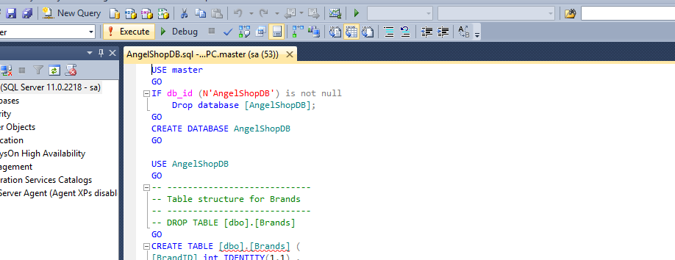

**Figure 4**: Thực thi file “**AngelShopDB*.sql*”**.

- If executing sql file successfully, some Messages will be shown (*Figure 6*).

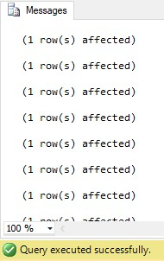

**Figure 5**: Executed sql file successfully.

* Quit “SQL Server Managerment Studio”.

# Step 3: Work with GLASSFISH SERVER

* Copy file **“sqljdbc4-2.0.jar”** to the lib folder of Glassfish as below (*Figure 12*)

C:\Program Files\glassfish-4\glassfish\domains\domain1\lib\ext

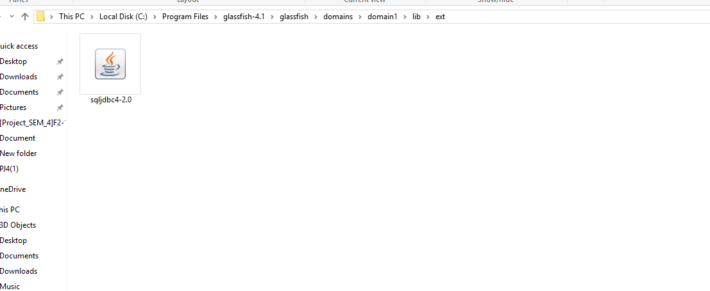

**Figure 6:** Copy file “**sqljdbc4-2.0.jar**” to glassfish library folder

- Open file “asenv.bat” (with notepad) in below address :

C:\Program Files\glassfish-4\glassfish\config

* Append below line to the end of file “asenv.bat” (*Figure 13*). (*Note: Replace JDK address to your exact JDK address*)

set AS_JAVA=C:\Program Files\Java\jdk1.7.0_80

**Figure 7:**

Config file “asenv.bat”

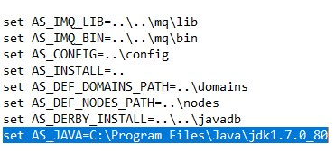

* Run file C:\Program Files\glassfish4\bin\asadmin.bat (*Note: replace with your exact glassfish folder*) as **administrator permission**.
* On opened console, type the command: **start-domain**. (*Figure 8)*

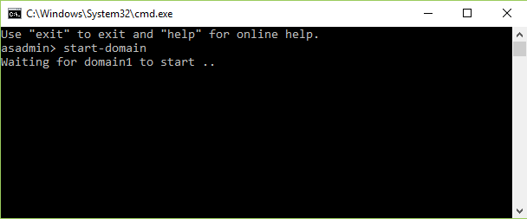

**Figure 8:** “Start” server Glassfish

- If starting server successfully, you will see “Admin Port: 4848” (*Figure 10*):

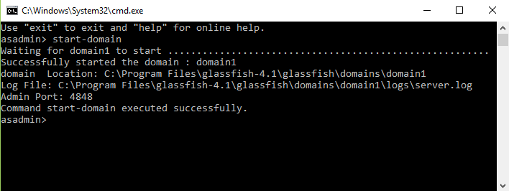

**Figure 9:** Started server successfully.

* **Note:** Do not close this console window during the website configuration is running.
* Open Chrome browser and enter the URL “http://localhost:4848” to enter Admin View Console of Glassfish server (*Figure 10)*.

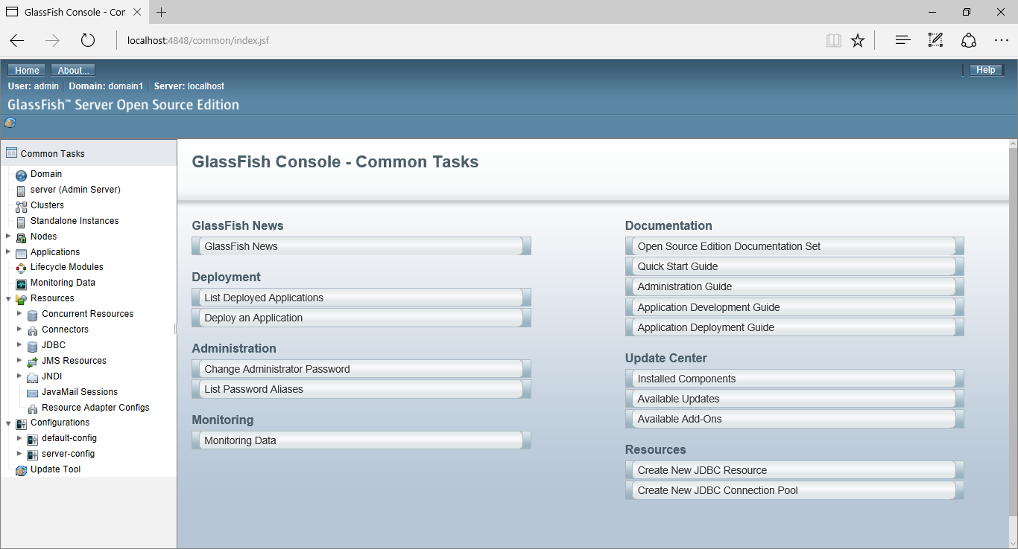

**Figure 10:** Glassfish admin console at “http://localhost:4848”.

# Step 4: Create “Connection Pool”

**-** At left menu of Glassfish admin console, click down arrow of item “JDBC”, click on item “JDBC Connection Pool”. (*Figure 11*).

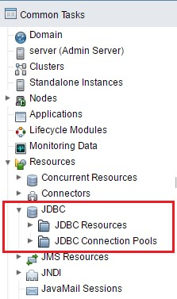

**Figure 11:** Select JDBC Connection Pools

* **-** Continue configuration with 2 steps:
* **At first screen of JDBC Connection Pool**: fill in below information: (*Figure 12*)

  **Pool Name:** AngelShopPool

  **Resource Type:** “select”javax.sql.ConnectionPoolDataSource

**Database Driver Vendor: “**select” MicrosoftSqlServer



 Click “**Next**”.

* **At second screen of JDBC Connection Pool:** in the frame “**Additional Properties**” fill below information to the column “Name” and “Value” (*Note: case-sensitive*) (*Figure 13*)

 **User:** sa

 **DatabaseName:** AngelShopDB

 **Password:** 123

 **ServerName:** localhost

 **URL:** jdbc:sqlserver://localhost:1433;databaseName=AngelShopDB

 **PortNumber:** 1433

 Add property with “Name” and “Value” :

* **Name:** driverClass
* **Value:** com.microsoft.sqlserver.jdbc.SQLServerDriver

 Click **Finish** to proceed to successful screen (*Figure 14*)..

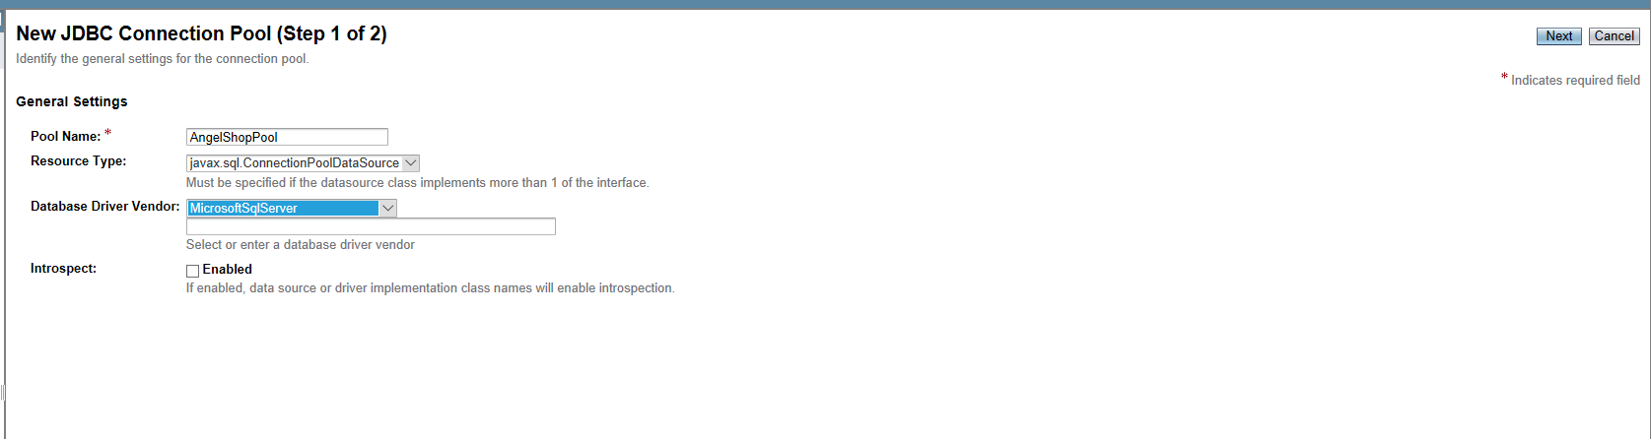

**Figure 12:** The first screen of JDBC Connection Pool

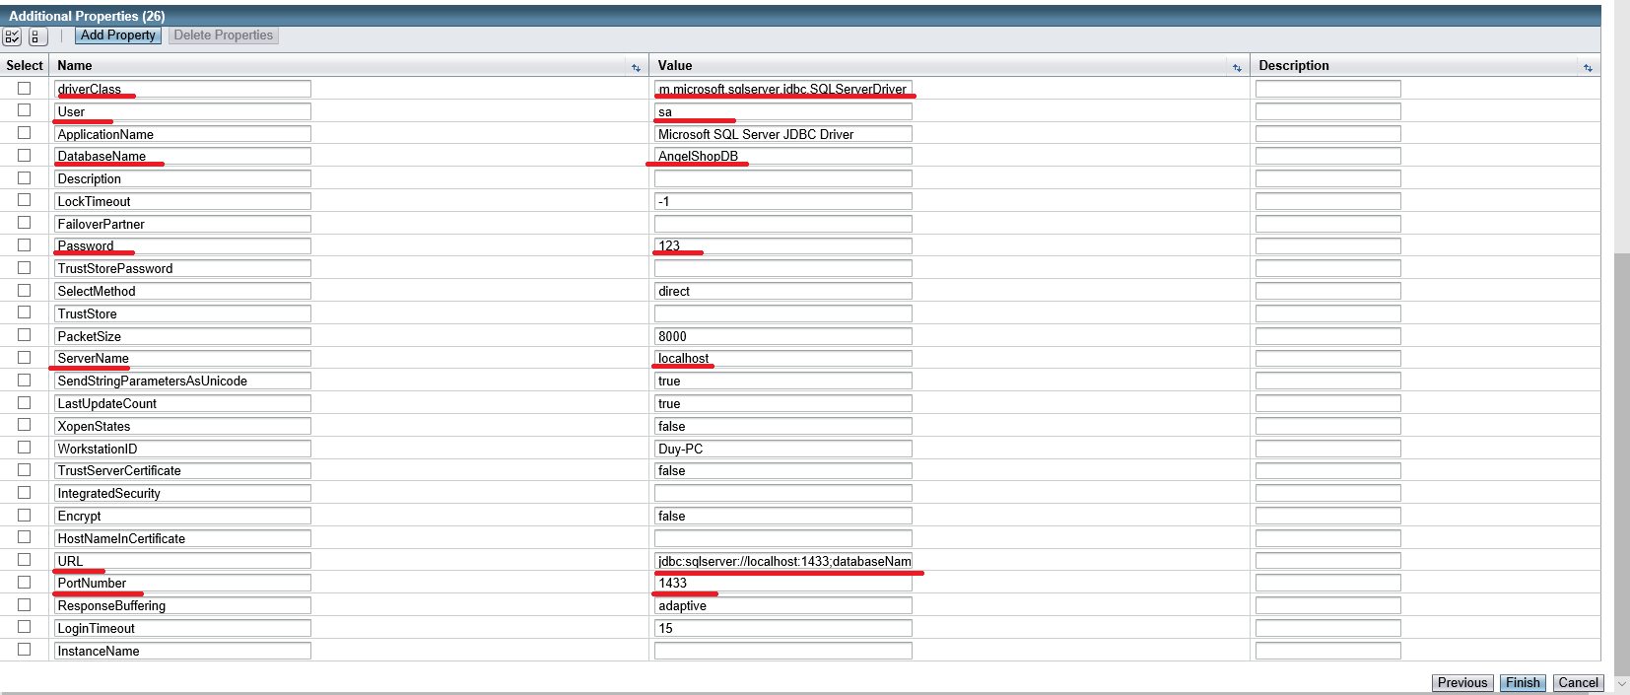

**Figure 13:** The second screen of JDBC Connection Pool

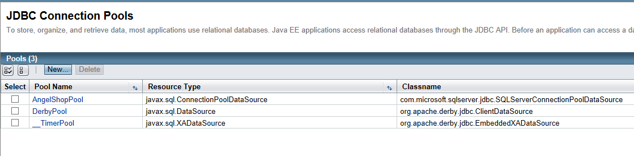

**Figure 14:** Successfully created JDBC connection pool.

* + On the JDBC Connection Pools screen, click on pool name “AngelShopPool” to go to pool details screen.
  + At pool details screen, click on “Ping” to check connection pool. If Glassfish informs “Ping Succeeded”, the connection pool is successfully created (*Figure 15*)

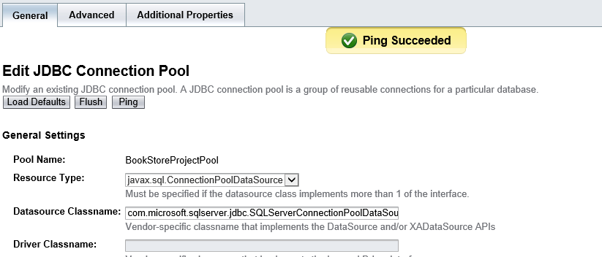

**Figure 15:**

Ping to check “Connection Pool”

# Step 5 : Create “JDBC Resources”

* At left menu of Glassfish admin console, click “JDBC Resources” to open below screen (*Figure 16*)

**Figure 16 :**

JDBC Resources

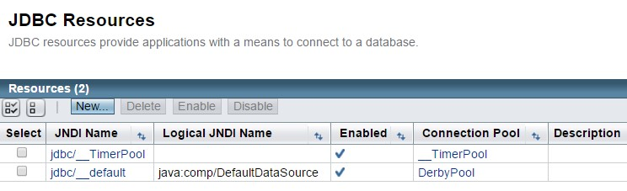

* Click on “New” to create a new JDBC resource.
* On New JDBC Resource screen, fill below information to corresponding fields (*Figure 17*)



**JNDI Name:**

jdbc/angelshop



**Pool Name:**

“Select” AngelShopPool



Click “OK” to create a new JDBC resource.

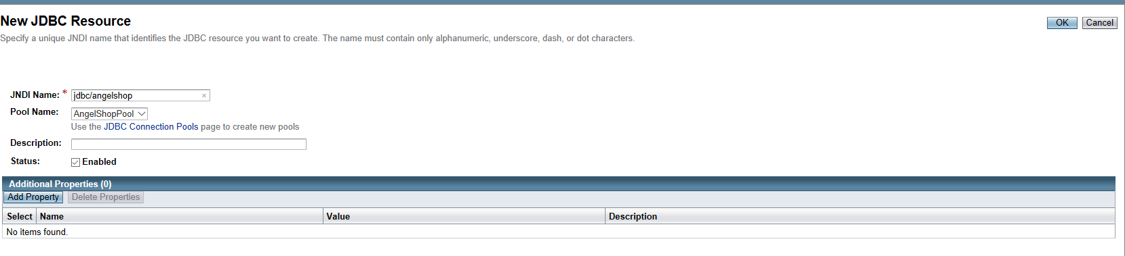

**Figure 17:** Create a new JDBC Resource

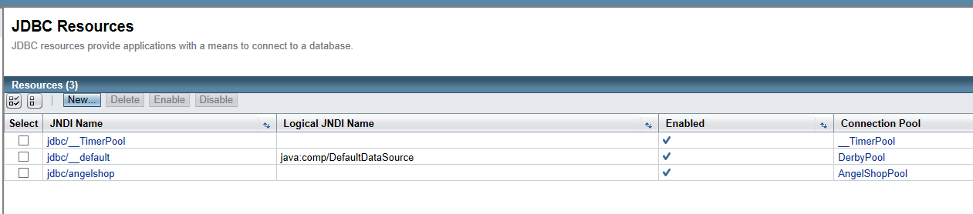

**Figure 18:** Successfully created a new JDBC resource

# Step 6: “Deploy” web application to server

At homepage of Glassfish admin console (http://localhost:4848), at the right side, select “Deploy an Application” (*Figure 19*):.

On Deploy Applications or Modules screen, select first field “**Packaged File to Be Uploaded to the Server”**, point to file **“AngelShop.war”** and click on OK button (*Figure 20*)

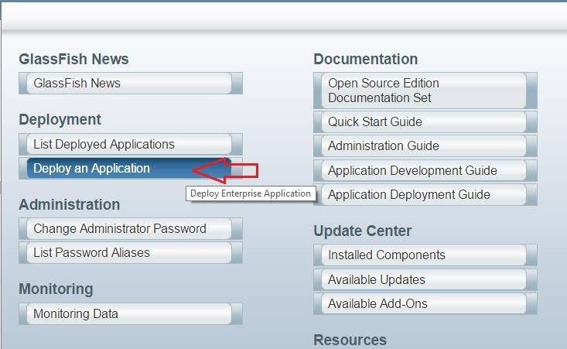

**Figure 19:** At right menus, select “Deploy an Application”

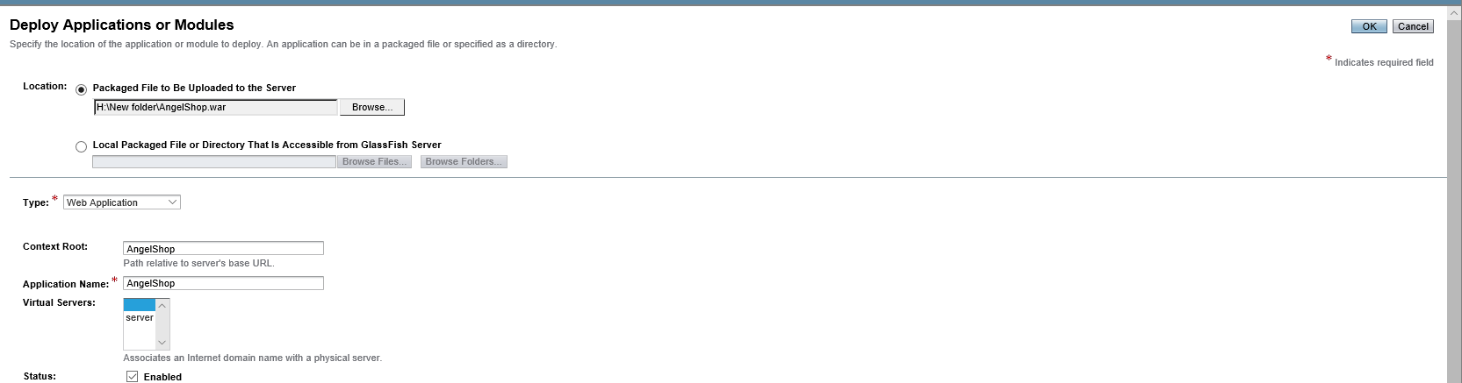

**Figure 20: Point to file** “**AngelShop.war”**

* It will take a long time for the server to deploy the app, so you should wait for a while. After deploying successfully, below screen will be shown (*Figure 21*):.

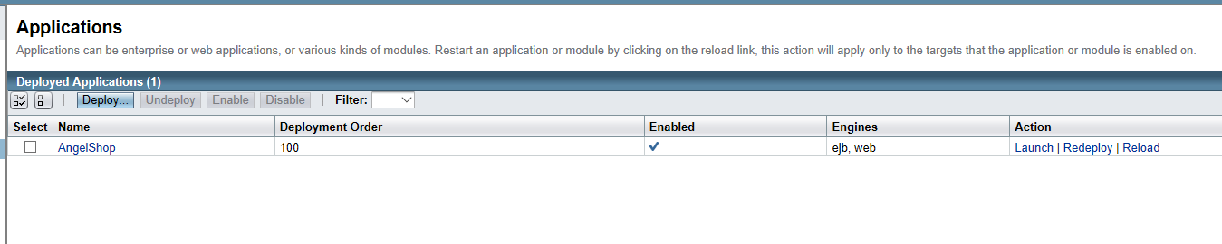

**Figure 21:** Successfully deployed application

* On screen above, click “Launch” to run the website (*Figure 22*) (**Note:** select path with “http://”):

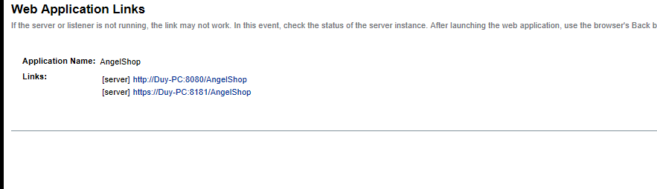

**Figure 22:** Click on path “http://” to run website.

* **-** After clicking on path “http://”, browser will show the website as below (*Figure 23*):

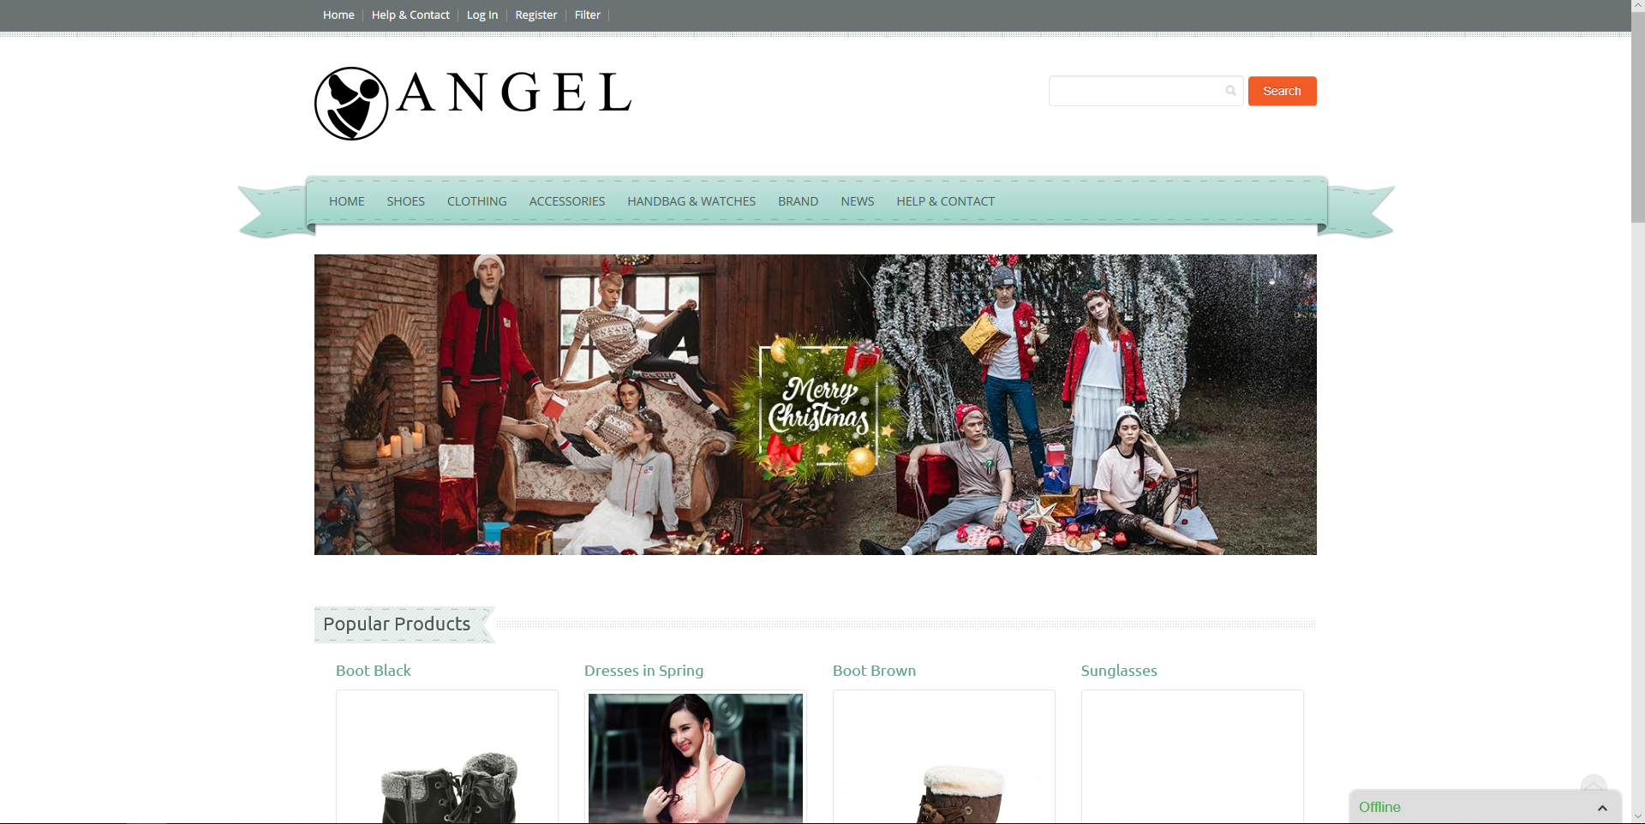

**Figure 23:** Successfully deployed **ANGEL SHOP** website.

**Instructor**

Phan Minh Tâm